1.Add a 10GB Disk to the centos.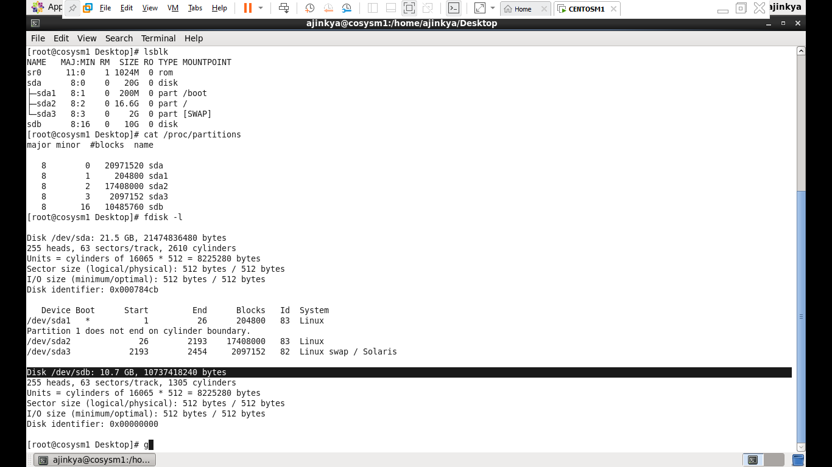

2.Create 2 Partitions 4Gb and 6Gb of space respectively.

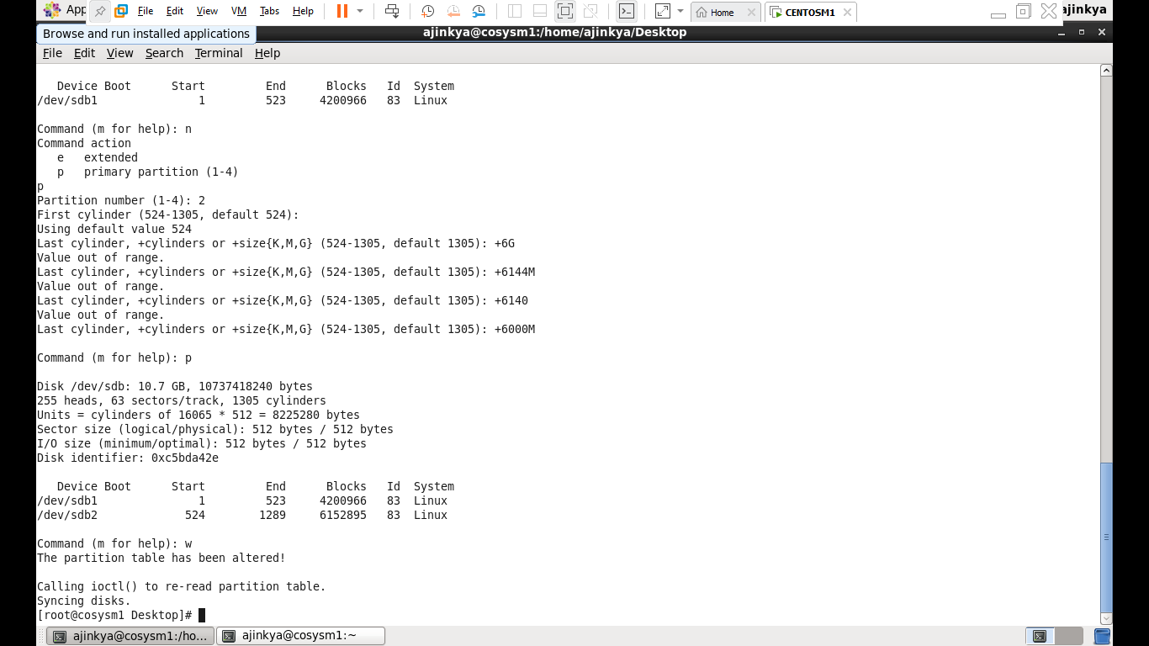

3.Format 4Gb with xfs and 6Gb with ext4 file system

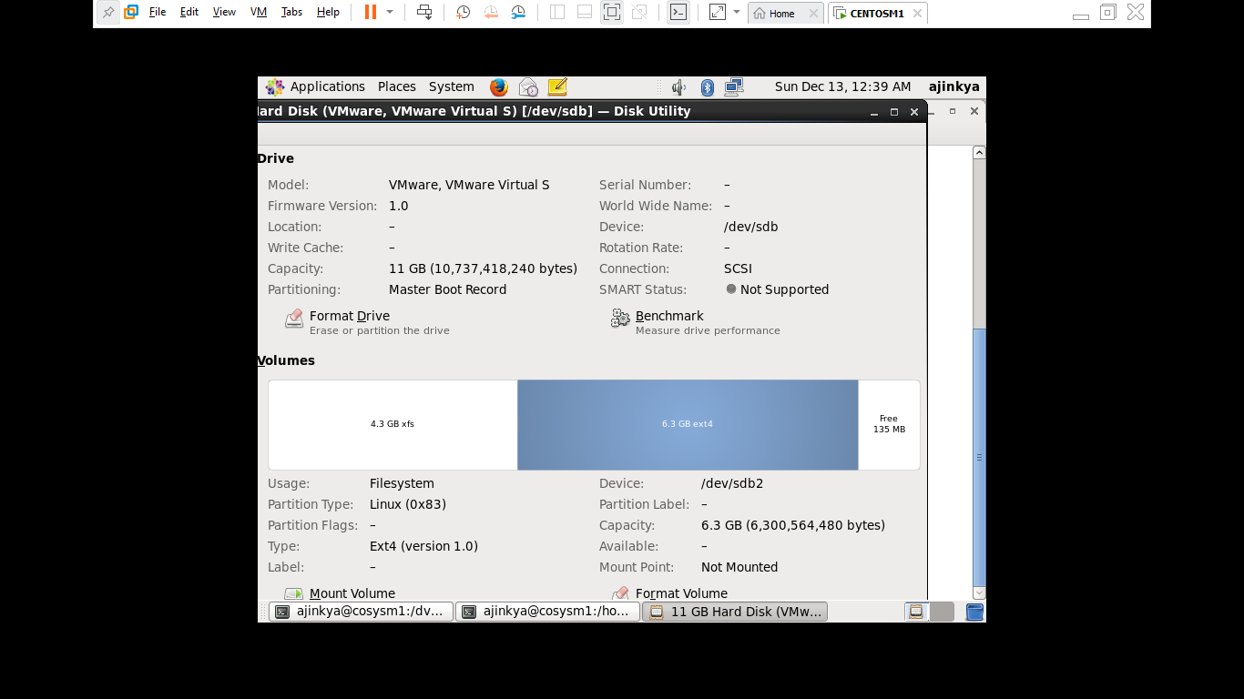

4.Mount 4Gb and 6Gb in /data and /music directory respectively

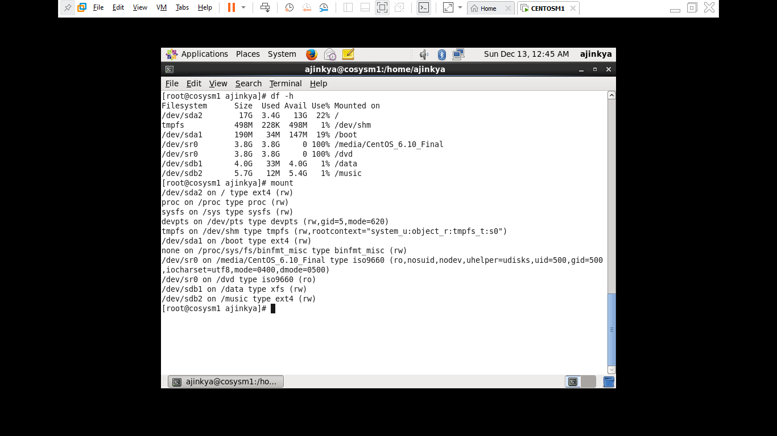

5.Create one file of 1Gb in each of the mount point created above.

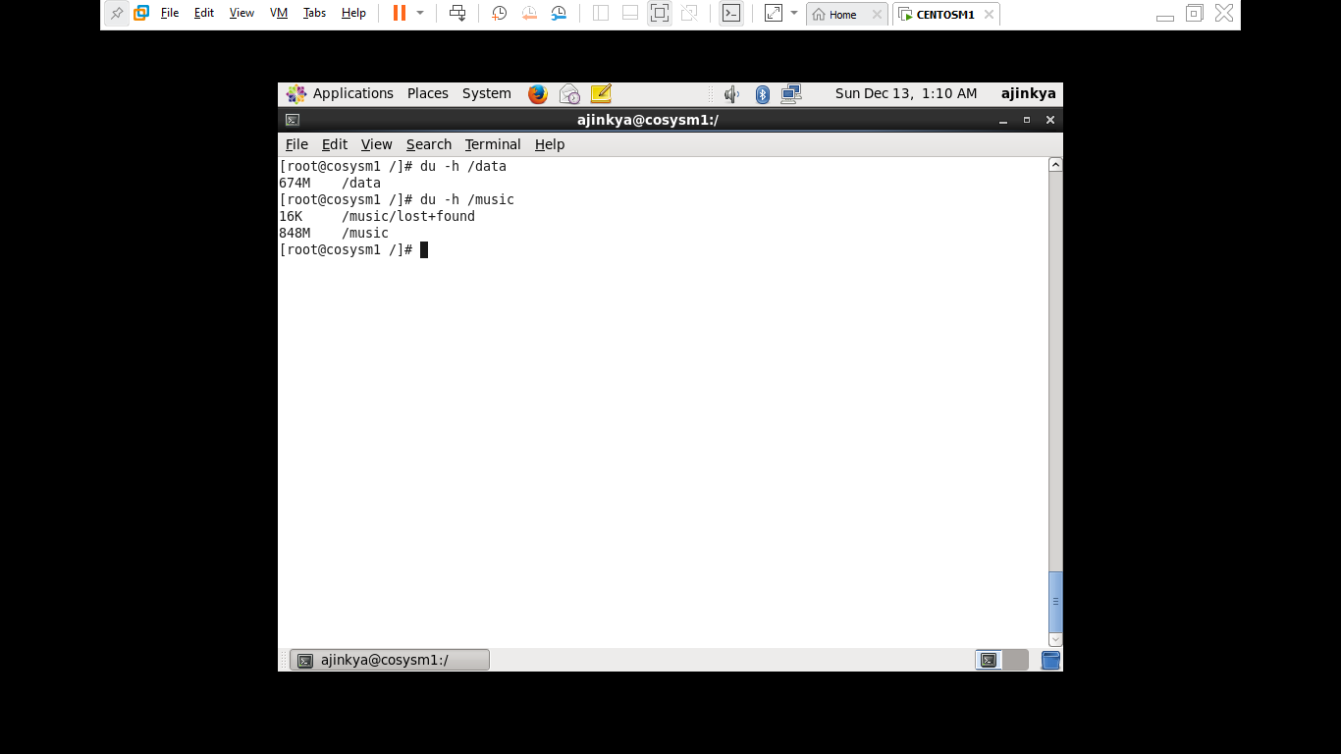

6. Verify the disk Consumption and disk space free in the mounted partitions

